User

Manual

Claim Registration

**Version 6.5**

|  |  |
| --- | --- |
| ***Corporate Office*** | ***Offshore Development Center*** |
| *1 Pickering Street*  *#06-03 Great Eastern Centre*  *Singapore 048659* | *Plot # 122 & 123, N.S.E.Z, Phase -2*  *NOIDA, UP 201 305*  *India*  *Tel: 91.11.91.2510483* |

|  |  |  |  |  |  |
| --- | --- | --- | --- | --- | --- |
| **Author** | | | | | |
| **Name** | **Role** | **Date of Preparation** | **Signature** | | |
| Varun Gupta | Business Analyst | 30-Jan-2015 | Varun | | |
| **Reviewer(s)** | | | | | |
| **Name** | **Role** | **Date of Review** | **Signature** | | |
| Pravesh Kumar | Manager Projects |  |  | | |
|  |  |  |  | | |
| **Approver** | | | | | |
| **Name** | **Role** | **Date of Approval** | **Signature** | | |
| ChengChoon Yip | VP Ebix Exchange  Asia |  |  | | |
| **Document Path** | **Version Number** | **Date of Release** | | | |
|  | 2.4 | 5 March 2015 | | | |
|  | 4.0 | 31st March 2015 | | | |
|  | 5.0 | 1 April 2015 | | | |
|  | 5.1 | 15 April 2015 | | | |
|  | 5.2 | 11 May 2015 | | | |
|  | 6.0 | 16 june 2015 | | | |
|  | 6.1 | 17 Jun 2015 | | | |
|  | 6.2 | 23 june 2015 | | | |
|  | 6.3 | 24 june 2015 | | | |
|  | 6.4 | 30 June 2015 | | | |
|  | 6.5 | 7 July 2015 | | | |
| **Revision History** | | | | | |
| **Version Number** | **Date of Release** | **Section/ Page # Changed** | | | **Details of Changes** |
| 1.0 | 5 March 2015 | Created document for system admin module | | | Whole document Created |
| 4.0 | 31st March 2015 | 23 / 115 | | | Added upload module |
| 5.0 | 1 April 2015 | Whole document | | | Changed sequence of Menus as per actual system admin master sequence. |
| 5.1 | 15 April 2015 | 5.1.4 Select Permission List Screen | | | Updated as per latest requirement of security management |
| 5.2 | 11 May 2015 | Section 12, 13 and 28 | | | FAL, Common master manual and LOG Request module’s user manual added |
| 6.0 | 16 june 2015 | Removed all section except claim registration module | | | Claim Registration Module |
| 6.1 | 17 June 2015 | Entire document | | | Minor editing |
| 6.2 | 23 June 2015 | Added document for screens | | | Accident, claims, service provider , tasks, notes, attachment |
| 6.3 | 24 June 2015 | Added document for screens | | | Diary, reserve, mandate and transaction History |
| 6.4 | 30 June 2015 | 9.1 and 10.2 section | | | Claims screen and service provider screens fields details |
| 6.5 | 7 July 2015 | Entire document | | | Edited sentences throughout the document |
| **References** | | | | | |
| **Document** | | **Date Received** | | **Author** | |
|  | |  | |  | |

Contents

1 Reference Points 5

2 Claim Registration Module 6

2.1 Description: 6

2.2 Screen information 6

3 New Claim Registration 7

3.1 Description 8

4 Incomplete Claim Registration Screen 9

4.1 Search screen snap shot 9

5 Claim Adjustment Menu 10

6 Claim Enquiry 11

7 LOG Request 12

7.1 Search screen 13

7.2 Home screen 14

7.3 New LOG Request screen 15

8 Accident Screen 16

8.1 Functionality description: 17

8.2 Accident Screen On new claim registration screen 19

8.3 Button functionality description 21

9 Claims Screen 22

10 Service Provider tab screen 23

10.1 Service Provider Grid Screen 24

11 Notes Screen 25

12 Tasks Screen 26

12.1 Grid Screen 27

12.2 Task Add screen 27

13 Attachment 29

14 Diary Tab Screen 30

14.1 Add diary Screen 31

15 Reserve Screen 32

15.1 Grid screen 32

15.2 Reserve Assign screen 33

16 Mandate Screen 35

16.1 Mandate Grid Screen. 35

16.2 Add Mandate Screen 36

16.2.1 Mandate Details section 36

16.2.2 Supervisor Approval Section 37

16.2.3 Claim Breakdown section. 37

17 Transaction History 38

# Reference Points

1. Mandatory fields are marked with an asterisk “*” sign.
2. If User presses save button without filling mandatory fields, validation error message will appear.
3. View screen will show records in read-only mode. User will not be able to edit any field.
4. On Edit screen for all masters, validation rules are the same.
5. Each screen will have created by and modified user names along with time stamp details also.

# Claim Registration Module

## Description:

* Claim Registration Module provide menu interface to user for below mentioned sub menu access:
  + New Claim Registration
  + Incomplete Claim Registration
  + Claim Adjustment
  + Claims Enquiry
* This menu will create unreported claims (Manual creation of claims).

## Screen information

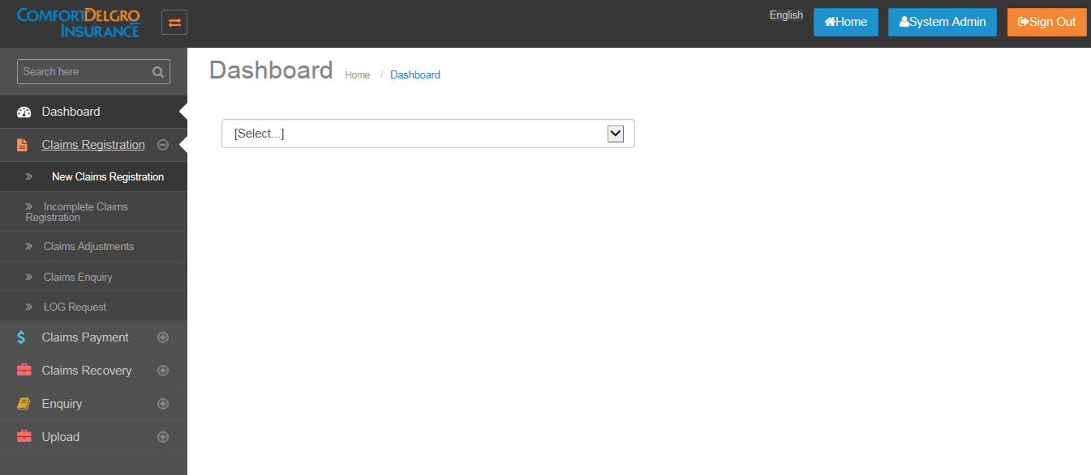

* Claim Registration module appears on left side pane of home screen.
* By Default claim Registration menu will come in expand (+) mode and user can click on “+” button to view submenu.

# New Claim Registration

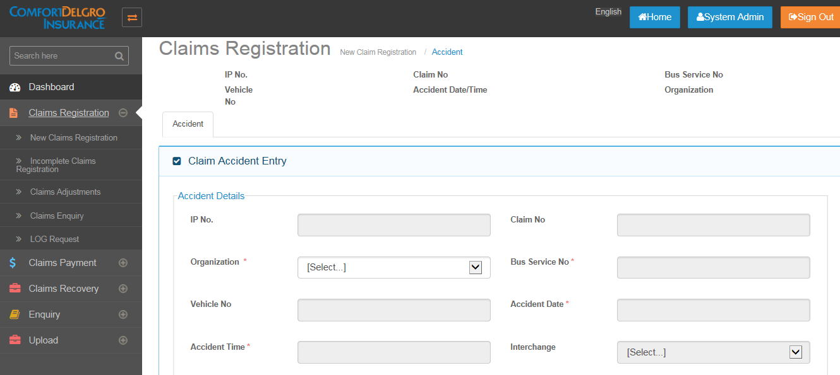

## Description

* New Claim registration will be created when user want to create manual claims ( unreported claims)
* Under New Claim registration , user can insert values in following screens:
  + Accident
  + Claims
  + Service provider
  + Notes
  + Tasks
  + Attachments
  + Diary
  + Reserve

**Note:**

In new claim registration menu, Accident screen will first show only “organization” field in editable mode and once organization is entered, all other fields will be enabled for editing. Please see below attachment:

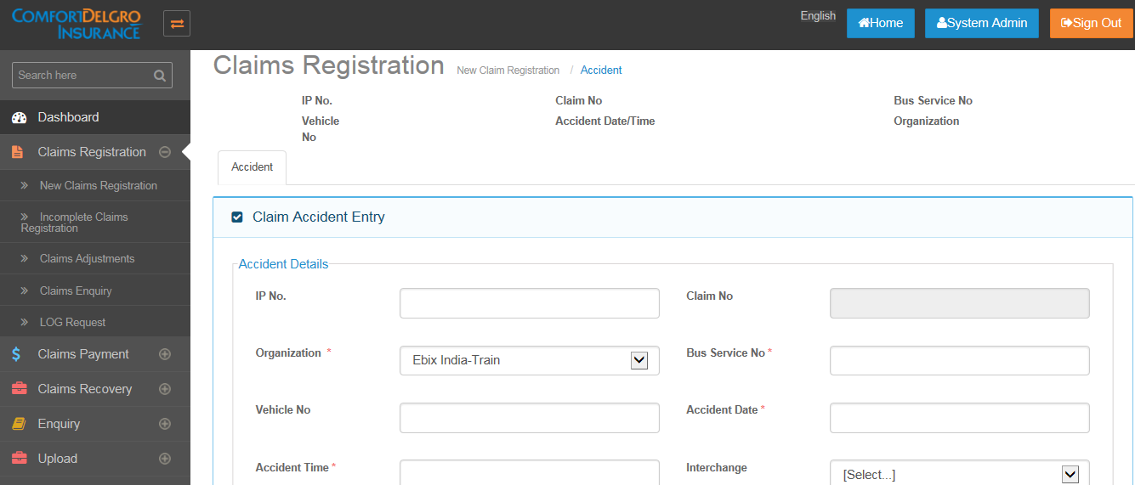

* Please find below list of tab screens accessibility information on new claim registration menu.
* No shows that that screen will neither hidden or grayed out for the menu.

|  |  |
| --- | --- |
| Accident | No |
| Claims | Hide |
| Service Provider | Hide |
| Notes | Hide |
| Tasks | Hide |
| Attachments | Hide |
| Diary | Hide |
| Reserve | Hide |
| Mandate | Hide |
| Payment | Hide |
| Recovery | Hide |
| Transaction History | Hide |

# Incomplete Claim Registration Screen

* After saving new claim registration -> accident screen, unreported claim number will be generated and claim will flow to incomplete claim search screen.

## Search screen snap shot

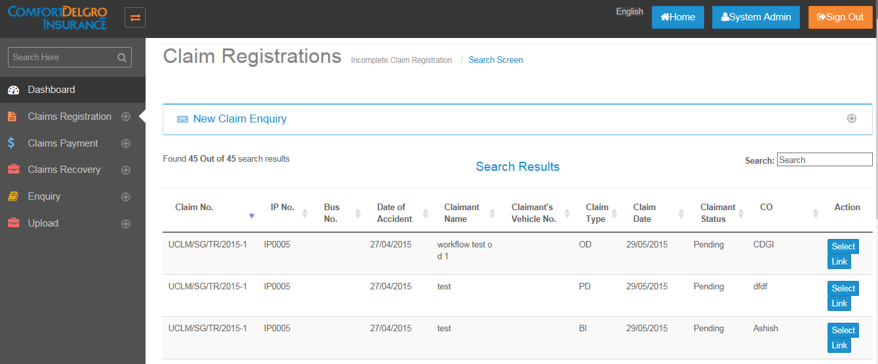

* Please find below list of tab screens accessibility information :
* “No” shows that that screen will neither hide or grayed out for the menu.

|  |  |
| --- | --- |
| Accident | No |
| Claims | Activated only when Any Own Damage = Yes, Any Property Damage / Bodily Injury = Yes else Grayed Out. Grayed Out means user can only see the Tab but clicking on it will do nothing. |
| Service Provider | Activated only when any OD, PD, BI Claims are created else Grayed Out. |
| Notes | No |
| Tasks | Activated only when any OD, PD, BI Claims are created else Grayed Out. |
| Attachments | Activated only when any OD, PD, BI Claims are created else Grayed Out. |
| Diary | No |
| Reserve | Activated only when any OD, PD, BI Claims are created else Grayed Out. |
| Mandate | Grayed Out |
| Payment | Grayed Out |
| Recovery | Grayed Out |
| Transaction History | No |

# Claim Adjustment Menu

* Once mandatory fields of claim and accident screen has been filled and user click on complete button on incomplete claim registration menu -> accident screen, record will flow to claim adjustment menu.
* This menu is primarily used for reserve adjustment and mandate request/approval.
* Please find below list of tab screens accessibility information :
* “No” shows that that screen will neither hide or grayed out for the menu and user will be able to edit on the screen.

|  |  |
| --- | --- |
| Accident | No |
| Claims | No |
| Service Provider | No |
| Notes | No |
| Tasks | No |
| Attachments | No |
| Diary | No |
| Reserve | No |
| Mandate | No |
| Payment | Grayed Out |
| Recovery | Grayed Out |
| Transaction History | **No** |

# Claim Enquiry

* All finalized claims will appear in the Claims Enquiry search screen.
* User can export information in Microsoft Excel format from the Claims Enquiry menu.
* Only claimant status on claim screen will be editable and user can reopen any finalized claim.
* Please find below list of tab screens accessibility information :

|  |  |
| --- | --- |
| Accident | View Only – Not Editable |
| Claims | Claimant Status Field Is Editable – Shows Only Reopened Option |
| Service Provider | View Only – Not Editable |
| Notes | View Only – Not Editable |
| Tasks | View Only – Not Editable |
| Attachments | View Only – Not Editable |
| Diary | View Only – Not Editable |
| Reserve | View Only – Not Editable |
| Mandate | View Only – Not Editable |
| Payment | View Only – Not Editable |
| Recovery | View Only – Not Editable |
| Transaction History | View Only – Not Editable |

# LOG Request

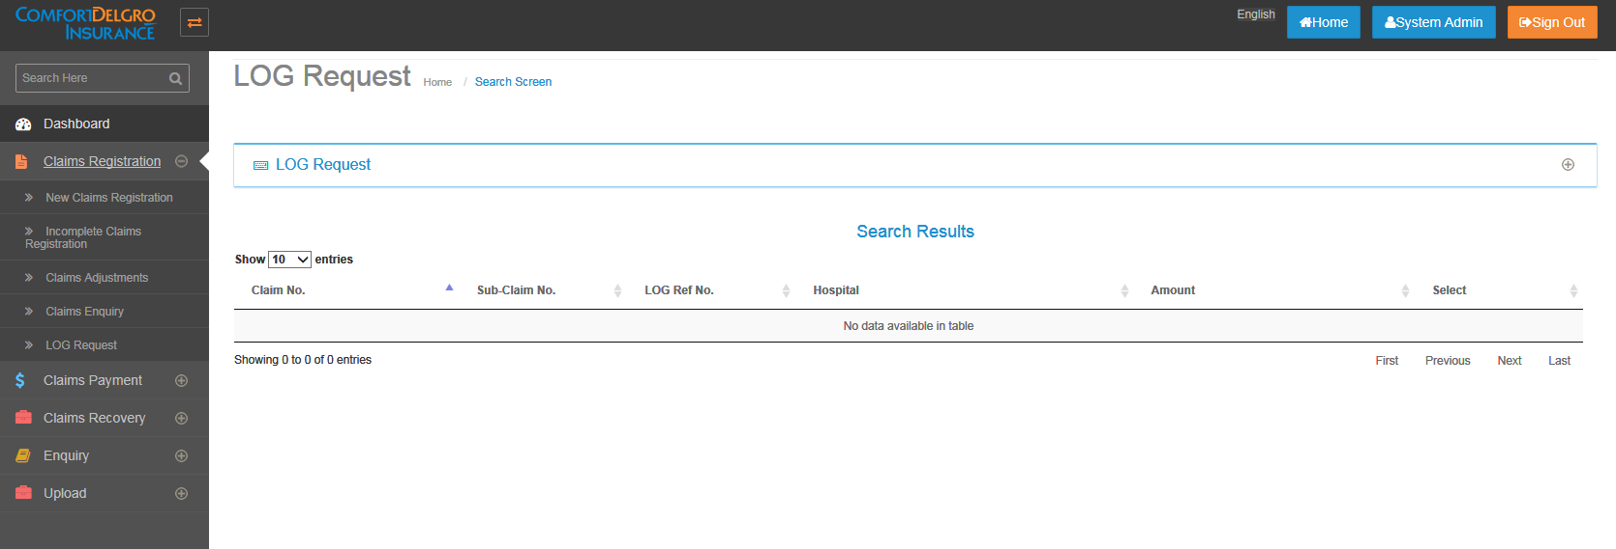

* LOG Request screen will appear in left side menu under Claims Registration module.
* Only when TPBI Claims is created and when there is Approved Mandate Amount for LOG Medical Expenses Field, then that Claim Number will flow to the LOG Request Screen for user to click on Create button to create LOG Request.
* Approved Mandate Amount for LOG Medical Expenses Field will populate the LOG Amount in the LOG Request Screen and will not be editable.
* Claimant Name will populate the Name created with the TPBI Claim and will not be editable.
* Once User clicks on Save, LOG Reference Number will be generated and the Search Display Results will populate the LOG Reference Number and the Hospital Name

## Search screen

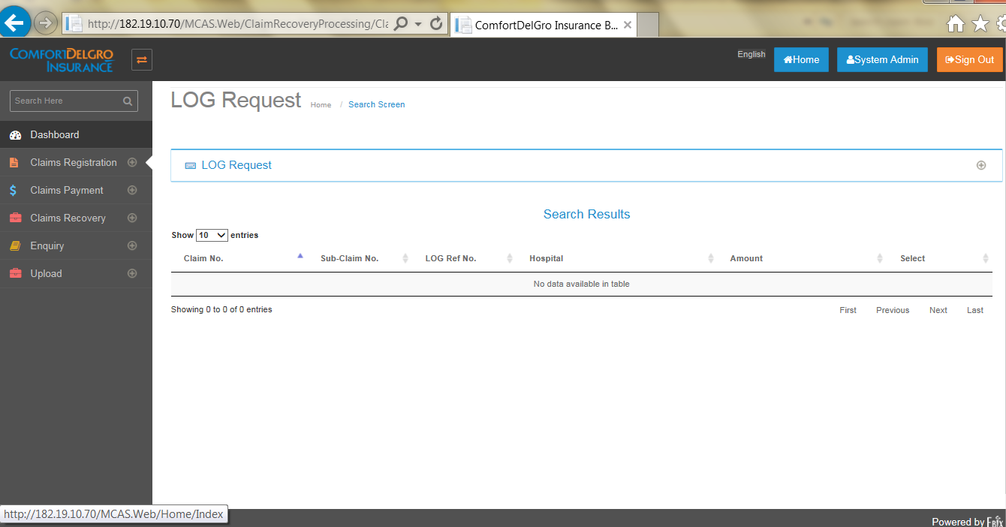

## Home screen

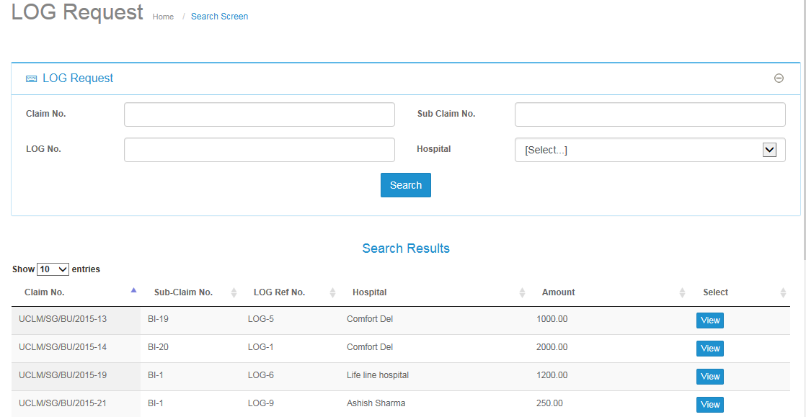

* User can view the list of LOG Requests created so far in search result section.
* User can also search LOG Requests by filling up search criteria.
* If user clicks on View button below mentioned screen will appear.

## New LOG Request screen

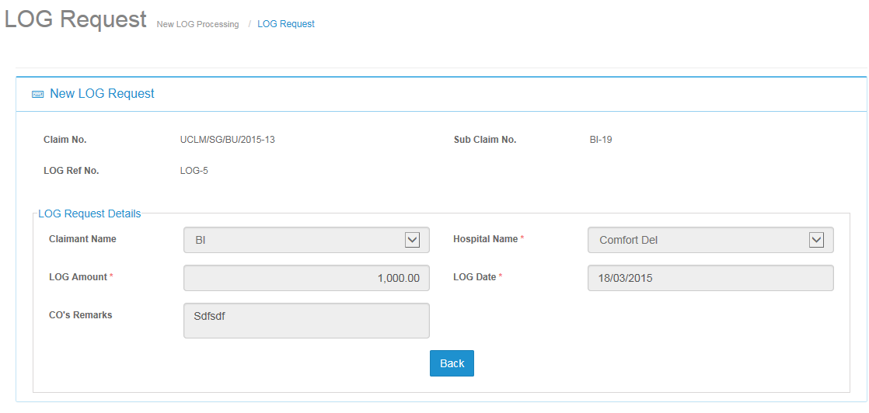

* Once User clicks on “Save” Button, LOG will be created.

# Accident Screen

## Functionality description:

1. Accident screen is used for saving primary information related to accident.

* Please find below list of fields in accident screen:

|  |  |  |  |  |
| --- | --- | --- | --- | --- |
| **S/N** | **Field Name** | **Field Type** | **Input Type** | **Input Selection** |
| 1 | IP No. | Textbox | Alphanumeric | Free text |
| 2 | Claim No | Textbox | Alphanumeric | Free text |
| 3 | Bus Service No | Textbox | Alphanumeric | Free text |
| 4 | Vehicle No | Textbox | Alphanumeric | Free text |
| 5 | Accident Date | Textbox | Date | (DD/MM/YYYY) |
| 6 | Accident Time | Textbox | Time | (HH:MM) |
| 7 | AM/PM | Radio-button | Alphanumeric | AM PM |
| 8 | Organization | Drop-down | Alphanumeric |  |
| 9 | IP No. | Textbox | Alphanumeric | Free text |
| 10 | Claim No | Textbox | Alphanumeric | Free text |
| 11 | Bus Service No | Textbox | Alphanumeric | Free text |
| 12 | Vehicle No | Textbox | Alphanumeric | Free text |
| 13 | Accident Date | Textbox | Date | (DD/MM/YYYY) |
| 14 | Accident Time | Textbox | Time | (HH:MM) |
| 15 | AM/PM | Radio-button | Alphanumeric | AM PM |
| 16 | Organization | Drop-down | Alphanumeric |  |
| 18 | Reported Dates | Textbox | Date | (DD/MM/YYYY) |
| 19 | Facts | Textbox | Alphanumeric | Free text |
| 20 | Damages | Textbox | Alphanumeric | Free text |
| 21 | Accident Location | Textbox | Alphanumeric | Free text |
| 25 | Recoverable (OD) | Radio-button | Alphanumeric | Yes No |
| 26 | Recoverable From Insurer (BI) | Radio-button | Alphanumeric | Yes No |
| 26 | Any Own Damage Claim | Radio-button | Alphanumeric | Yes No |
| 27 | Any Property Damage /Bodily Injury Claim | Radio-button | Alphanumeric | Yes No |
| 28 | Date of Finding | Textbox | Date | (DD/MM/YYYY) |
| 29 | Invest. Status | Drop-down |  | START WORK WORKDED 30 MINS WORKDED 1 HR WORKDED 1 HR 30 MINS WORKDED 2 HRS WORKDED 2 HRS 30 MINS WORKDED 3 HRS WORKDED 3 HRS 30 MINS WORKDED 4 HRS WORKDED 4HRS 30 MINS WORKDED 5 HRS WORKDED 5 HRS 30 MINS WORKDED 6 HRS WORKDED 6 HRS 30 MINS WORKDED 7 HRS WORKDED 7 HRS 30 MINS WORKDED 8 HRS WORKDED 8 HRS 30 MINS WORKDED 9 HRS WORKDED 9 HRS 30 MINS WORKDED 10 HRS WORKDED 10 HRS 30 MINS WORKDED 11 HRS WORKDED 11 HRS 30 MINS WORKDED 12 HRS WORKDED exceeded 12 HRS |
| 30 |  | Textbox | Alphanumeric | Please see below for full list of input selections |
| 31 | BOI Results | Textbox | Alphanumeric | Free text |
| 32 | Final Liability | Drop-down | Alphanumeric | Fully At Fault Not At Fault Partial At Fault |
| 33 | Duty IO | Textbox | Alphanumeric | Free text |
| 34 | Vehicle No | Textbox | Alphanumeric | Free text |
| 35 | Make | Textbox | Alphanumeric | Free text |
| 36 | Model | Textbox | Alphanumeric | Free text |
| 37 | Bus Captain code | Textbox | Alphanumeric | Free text |
| 38 | Bus Captain Name | Textbox | Alphanumeric | Free text |
| 39 | NRIC No | Textbox | Alphanumeric | Free text |
| 40 | Mobile No | Textbox | Alphanumeric | Free text |

## Accident Screen On new claim registration screen

* User needs to select an organization from the drop down list and then other fields will become editable.

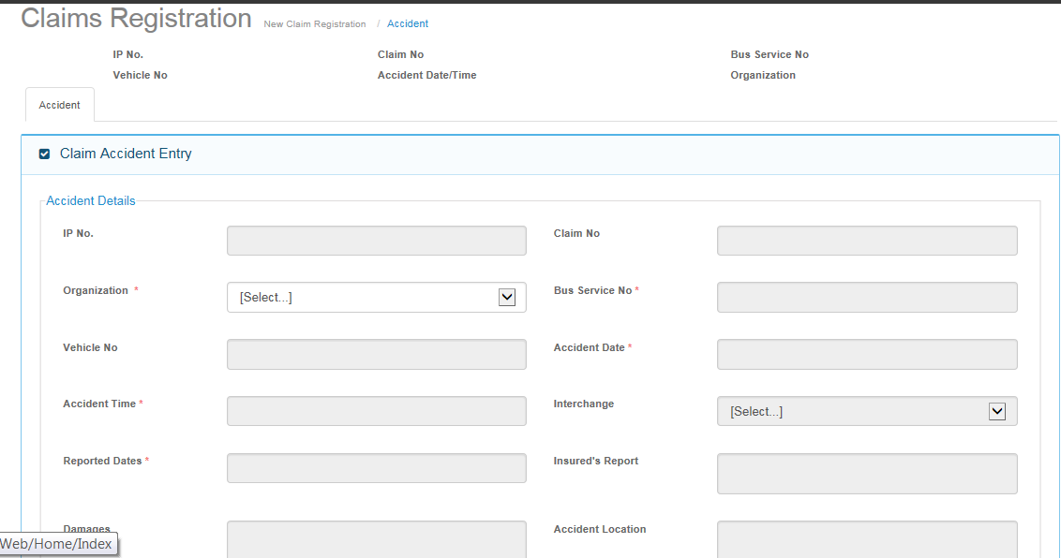

* Main functional points:
  + If user select field “yes” for recoverable (OD) and Recoverable (BI) then all claimant record number will become eligible for recovery module.
  + User has to select one of the two radio button from “Any own damage” and “Any property damage” radio button as “yes”.
  + On click of retrieve button under Vehicle Master, user can view make and model for entered vehicle number.

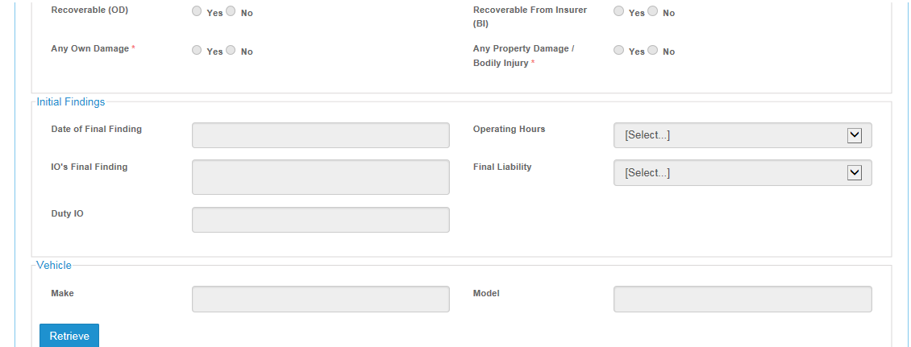

## Button functionality description

* Save button: Upon clicking the Save button, system will check validation of mandatory fields and generate a unique unreported claim number.
* Reset button: Reset button will clear all entered fields’ data.
* Complete Button: This button will check validation of mandatory fields of accident screen and at least once claims screen information and if all mandatory fields are filled then mark that claim as complete and move it to claim adjustment menu.
* Preview Document: This button will show document list to be generated.
* Cancel button: This Button is for UCLM Claims (Unreported Claims) only. Button will only be clickable when a UCLM Claim Number has been generated. When button is clicked, prompt user “Do You Want To Cancel This Accident Claim?” and two buttons “Yes” and “Cancel”. If yes, system will update “Accident Claim Has Been Canceled”. There will be no more editing allowed.

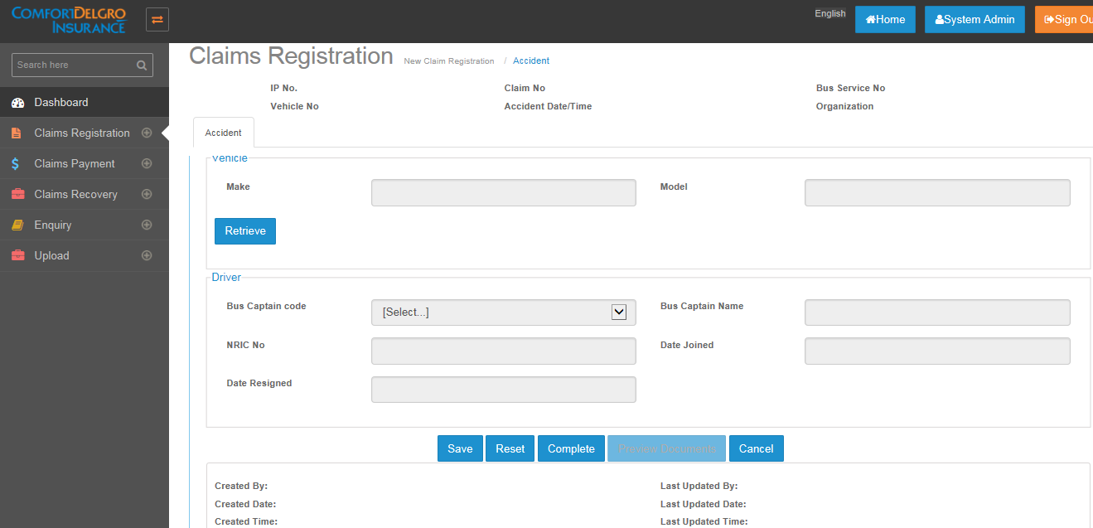

# Claims Screen

* User can create three type of claims under claims screen.
  + I) Own Damage (OD), ii) Property Damage ( TPPD ), iii) Body Injury (TPBI)

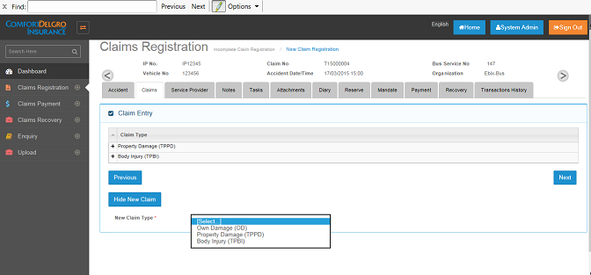

* By Default claimant status will be “Pending”.

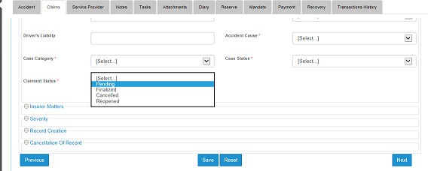

## Claims screen’s field details

|  |  |  |  |  |
| --- | --- | --- | --- | --- |
| **S/N** | **Field Name** | **Field Type** | **Input Type** | **Input Selection** |
| **Own Damage Screen Fields** | |  |  |  |
| 1 | Claimant Name: | Textbox | Alphanumeric | Free text |
| 2 | Claimant's NRIC/PP NO: | Textbox | Alphanumeric | Free text |
| 3 | Claimant's DOB: | Textbox | Date | (DD/MM/YYYY) |
| 4 | Claimant's Gender: | Radio-button | Alphanumeric | Male Female |
| 5 | Claimant's Type: | Drop-down | Alphanumeric | Commuter Pedestrian Vehicle Owner Company |
| 6 | Claimant's Address1 | Textbox | Alphanumeric | Free text |
| 7 | Claimant's Address2 | Textbox | Alphanumeric | Free text |
| 8 | Claimant's Address3 | Textbox | Alphanumeric | Free text |
| 9 | Claimant's Postal Code | Textbox | Alphanumeric | Free text |
| 10 | Claimant’s Contact No.: | Textbox | Alphanumeric | Free text |
| 11 | Claimant's Email: | Textbox | Alphanumeric | Free text |
| 12 | Vehicle Regn No.: | Textbox | Alphanumeric | Free text |
| 13 | Vehicle Make: | Textbox | Alphanumeric | Free text |
| 14 | Vehicle Model: | Textbox | Alphanumeric | Free text |
| 15 | Is claimant an infant? | Radio-button | Alphanumeric | Yes No |
| 16 | Infant's Name: | Textbox | Alphanumeric | Free text |
| 17 | Infant's NRIC: | Textbox | Alphanumeric | Free text |
| 18 | Infant's DOB: | Textbox | Date | (DD/MM/YYYY) |
| 19 | Infant's Gender: | Radio-button | Alphanumeric | Male Female |
| 20 | Claim Type | Drop-down | Alphanumeric | Own Damage |
| 21 | Record No | Textbox | Alphanumeric | Free text |
| 22 | Timebar Date | Textbox | Date | (DD/MM/YYYY) |
| 23 | Claim Date | Textbox | Date | (DD/MM/YYYY) |
| 24 | Claims Officer | Drop-down | Alphanumeric |  |
| 25 | Driver's Liability | Textbox | Numeric | 999 |
| 26 | Accident Cause | Drop-down | Alphanumeric | Insured Hit Parked TP Vehicle Changing Lanes Insured Reversing Insured into Rear of TP Vehicle Alleged Accident Roundabout Collision Multiple Vehicle Accident TP Turns across Oncoming Traffic Traffic Light Collision Insured Vehicle Hit - Parked Known Immobile Property (Excl Canopies)  Overtaking Insured Vehicle Hit in Rear Junction Collision Pedestrian Insured Turn across Oncoming Traffic TP Reversing TP Pulling In Insured Pulling into/from Parked Position Insured from Slip Road Cyclist |
| 27 | Case Category | Drop-down | Alphanumeric | Law Workshop Individual Insurer Malaysia Registered Vehicle MLAW SMRT Unknown TP Bus not damaged Counter-Claim |
| 28 | Case Status | Drop-down | Alphanumeric | Trial Check sent/received Negotiation Discharge Voucher sent/received Insurers Take Over Inactive Drop Installments CDR 1st Reminder 2nd Reminder Settlement at District For CO's Action Pending Documents (External) Pending Documents (Internal) Payment Processing Pre-Repair Letter of Demand sent/received WRIT Reject - CCTV Evidence Reject - Others Reject - Scene Photos Reject - Witness Statement Re-inspection |
| 29 | Claimant Status | Drop-down | Alphanumeric | Pending Finalized Cancelled Reopened |
| 30 | Final Settle Date | Textbox | Date | (DD/MM/YYYY) |
| 31 | Writ Issued | Textbox | Date | (DD/MM/YYYY) |
| 32 | Writ No. | Textbox | Alphanumeric | Free text |
| 33 | Sensitive Case | Textbox | Date | (DD/MM/YYYY) |
| 34 | Created by | Textbox | Alphanumeric | Free text |
| 35 | Created Date | Textbox | Date | (DD/MM/YYYY) |
| 36 | Reopened Date | Textbox | Date | (DD/MM/YYYY) |
| 37 | Late/Reopened | Textbox | Alphanumeric | Free text |
| 38 | Record Cancellation Date | Textbox | Date | (DD/MM/YYYY) |
| 39 | Record Cancellation Reason | Textbox | Alphanumeric | Free text |
|  |  |  |  |  |
| * **PD/BI Screen fields** | |  |  |  |
| **S.no** | **Field Name** | **Field Type** | **Input Type** | **Input Selection** |
| 1 | Claimant Name: | Textbox | Alphanumeric | Free text |
| 2 | Claimant's NRIC/PP NO: | Textbox | Alphanumeric | Free text |
| 3 | Claimant's DOB: | Textbox | Date | (DD/MM/YYYY) |
| 4 | Claimant's Gender: | Radio-button | Alphanumeric | Male Female |
| 5 | Claimant's Type: | Drop-down | Alphanumeric | Commuter Pedestrian Vehicle Owner Company |
| 6 | Claimant's Address1 | Textbox | Alphanumeric | Free text |
| 7 | Claimant's Address2 | Textbox | Alphanumeric | Free text |
| 8 | Claimant's Address3 | Textbox | Alphanumeric | Free text |
| 9 | Claimant's Postal Code | Textbox | Alphanumeric | Free text |
| 10 | Claimant’s Contact No.: | Textbox | Alphanumeric | Free text |
| 11 | Claimant's Email: | Textbox | Alphanumeric | Free text |
| 12 | Vehicle Regn No.: | Textbox | Alphanumeric | Free text |
| 13 | Vehicle Make: | Textbox | Alphanumeric | Free text |
| 14 | Vehicle Model: | Textbox | Alphanumeric | Free text |
| 15 | Is claimant an infant? | Radio-button | Alphanumeric | Yes No |
| 16 | Infant's Name: | Textbox | Alphanumeric | Free text |
| 17 | Infant's NRIC: | Textbox | Alphanumeric | Free text |
| 18 | Infant's DOB: | Textbox | Date | (DD/MM/YYYY) |
| 19 | Infant's Gender: | Radio-button | Alphanumeric | Male Female |
| 20 | Claim Type | Drop-down | Alphanumeric | Own Damage |
| 21 | Record No | Textbox | Alphanumeric | Free text |
| 22 | Timebar Date | Textbox | Date | (DD/MM/YYYY) |
| 23 | Claim Date | Textbox | Date | (DD/MM/YYYY) |
| 24 | Claims Officer | Drop-down | Alphanumeric |  |
| 25 | Driver's Liability | Textbox | Numeric | 999 |
| 26 | Accident Cause | Drop-down | Alphanumeric | Insured Hit Parked TP Vehicle Changing Lanes Insured Reversing Insured into Rear of TP Vehicle Alleged Accident Roundabout Collision Multiple Vehicle Accident TP Turns across Oncoming Traffic Traffic Light Collision Insured Vehicle Hit - Parked Known Immobile Property (Excl Canopies)  Overtaking Insured Vehicle Hit in Rear Junction Collision Pedestrian Insured Turn across Oncoming Traffic TP Reversing TP Pulling In Insured Pulling into/from Parked Position Insured from Slip Road Cyclist |
| 27 | Case Category | Drop-down | Alphanumeric | Law Workshop Individual Insurer Malaysia Registered Vehicle MLAW SMRT Unknown TP Bus not damaged Counter-Claim |
| 28 | Case Status | Drop-down | Alphanumeric | Trial Check sent/received Negotiation Discharge Voucher sent/received Insurers Take Over Inactive Drop Installments CDR 1st Reminder 2nd Reminder Settlement at District For CO's Action Pending Documents (External) Pending Documents (Internal) Payment Processing Pre-Repair Letter of Demand sent/received WRIT Reject - CCTV Evidence Reject - Others Reject - Scene Photos Reject - Witness Statement Re-Inspection |
| 29 | Claimant Status | Drop-down | Alphanumeric | Pending Finalized Cancelled Reopened |
| 30 | Final Settle Date | Textbox | Date | (DD/MM/YYYY) |
| 31 | Report sent to Insurer | Textbox | Date | (DD/MM/YYYY) |
| 32 | Referred To Insurers? | Checkbox |  | (DD/MM/YYYY) |
| 33 | Date Referred To Insurers | Textbox | Date | (DD/MM/YYYY) |
| 34 | Informed Insurer of Settlement | Textbox | Date | (DD/MM/YYYY) |
| 35 | Excess Recovered Date | Textbox | Date | (DD/MM/YYYY) |
| 36 | Writ Issued | Textbox | Date | (DD/MM/YYYY) |
| 37 | Writ No. | Textbox | Alphanumeric | Free text |
| 37 | Sensitive Case | Textbox | Date | (DD/MM/YYYY) |
| 39 | MP | Drop-down | Alphanumeric |  |
| 40 | Constituency | Drop-down | Alphanumeric |  |
| 41 | Date of MP letter | Textbox | Date | (DD/MM/YYYY) |
| 42 | Reference No | Textbox | Alphanumeric | Free text |
| 43 | Created by | Textbox | Alphanumeric | Free text |
| 44 | Created Date | Textbox | Date | (DD/MM/YYYY) |
| 45 | Reopened Date | Textbox | Date | (DD/MM/YYYY) |
| 46 | Late/Reopened | Textbox | Alphanumeric | Free text |
| 47 | Record Cancellation Date | Textbox | Date | (DD/MM/YYYY) |
| 48 | Record Cancellation Reason | Textbox | Alphanumeric | Free text |

# Service Provider tab screen

* User can assign Service Providers to claimant’s claims created in Claim Screen.
* Four types of Service Providers can be assigned
  + Insurer
  + Surveyor
  + Workshop
  + Lawyer
* One claimant can have n number of Service Providers.
* List of Service Providers will be populated from the Service Provider Master.

## Service Provider Grid Screen

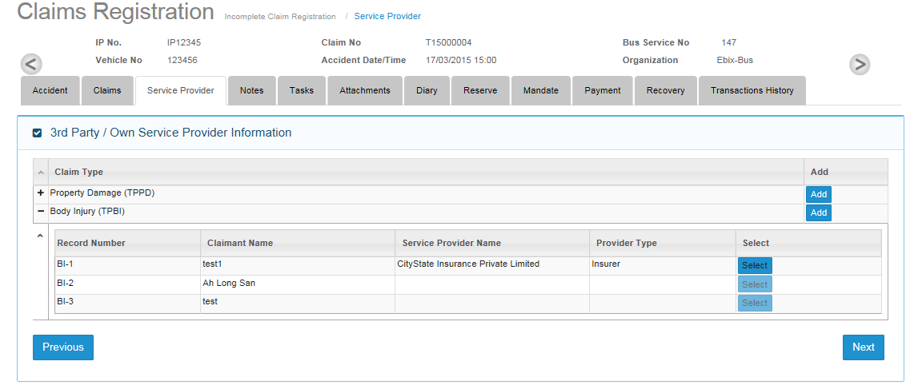

* Service provider grid screen will show the list of claimants added.
* User will click on “add” button to assign Service Providers to claimant created under selected claim type.
* “Select” button will appear as greyed out if there are no Service Providers added to the claimant.
* Select button will show details of added Service Providers.
* When user click on add button then user needs to select below values
  + Claimant name: drop down will show already added claimant name from claim screen.
  + Party Type : four party type available
    - Insurer
    - Surveyor
    - Workshop
    - Lawyer
  + Service provider type :
    - Own
    - Third Party
* Based on selection of above values, company names will be populated from Service Provider Master and can be selected from the drop down list.

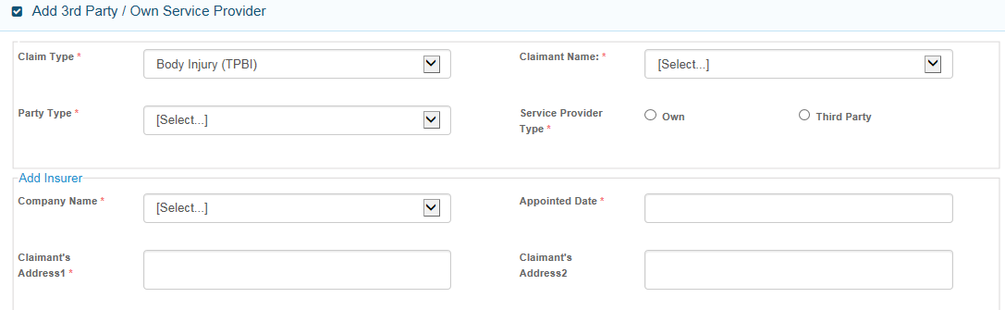

## Service Provider Fields Details

|  |  |  |  |  |
| --- | --- | --- | --- | --- |
| **Service Provider** | **Type** | **Field Type** | **Input Type** | **Input Selection** |
|  |  | Text / drop down/  radio button / check box | Text /Alphanumeric / number | Free text/ Dd-mm-yyyy /  Or values of drop down list |
| Claim Type | Populated | Drop down | Alphanumeric | OD Claim, TPPD Claim, TPBI Claim |
| Claimant Name | Editable | Drop down | Alphanumeric |  |
| Party Type | Editable | Drop down | Alphanumeric | Insurer, Surveyor, Lawyer, Workshop |
| Service provider type | Editable | Radio Button | Alphanumeric | Our / TP |
| Company Name | Populated | Drop down | Alphanumeric |  |
| Appointed Date | Editable | Text | Date Field |  |
| Address 1 | Populated | Text | Alphanumeric |  |
| Address 2 | Populated | Text | Alphanumeric |  |
| Address 3 | Populated | Text | Alphanumeric |  |
| City | Populated | Text | Alphanumeric |  |
| State | Populated | Text | Alphanumeric |  |
| Country | Populated | Text | Alphanumeric |  |
| Postal Code | Populated | Text | Numeric |  |
| Reference No | Populated | Text | Alphanumeric |  |
| 1st Contact Person's Name | Populated | Text | Alphanumeric |  |
| Email Address | Populated | Text | Alphanumeric |  |
| Office No | Populated | Text | Numeric |  |
| Mobile No | Populated | Text | Numeric |  |
| Fax No | Populated | Text | Numeric |  |
| 2nd Contact Person's Name | Populated | Text | Alphanumeric |  |
| Email Address | Populated | Text | Alphanumeric |  |
| Office No | Populated | Text | Numeric |  |
| Mobile No | Populated | Text | Numeric |  |
| Fax No | Populated | Text | Numeric |  |
| Insurer Type | Populated | Drop down | Alphanumeric | Own, TP, Both |
| Status | Populated | Text | Alphanumeric | Active, Inactive |
| Effective From | Populated |  |  |  |
| Effective To | Populated |  |  |  |
| Remarks | Editable | Text | Alphanumeric | Free text |

# Notes Screen

* User can add notes against created claimant name.
* Note Date and Note Time field will be created automatically upon clicking on the Save button.

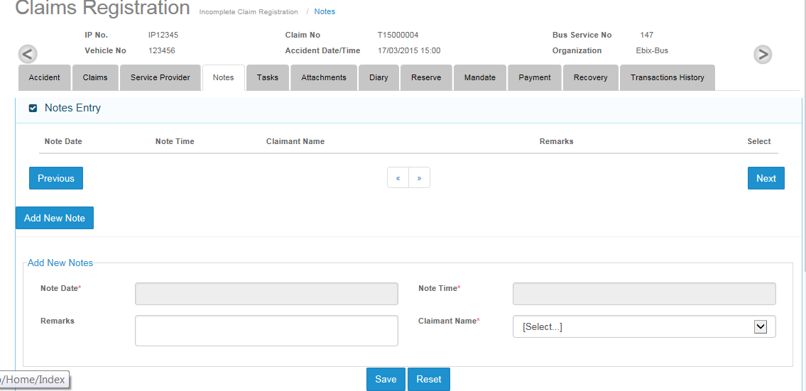

# Tasks Screen

## Grid Screen

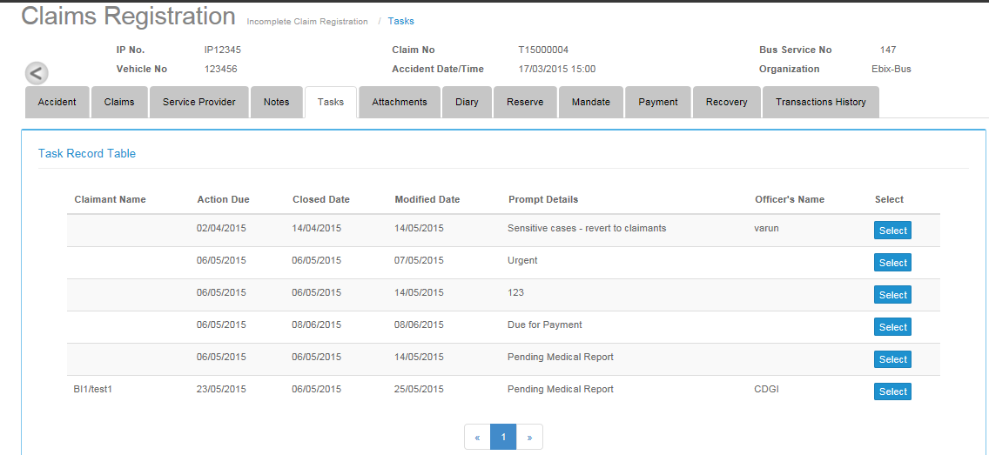

* Task screen will show grid having following columns
  + Claimant name
  + Action Due
  + Closed Date
  + Modified Date
  + Prompt Details
  + Officer’s name
  + Select
* Grid will show two colored rows as per following
  + Yellow: when current date is less than to 3 days to action due date or equal to action date and task is not yet closed.
  + Red: when current date passed action due date and task is not yet closed.

## Task Add screen

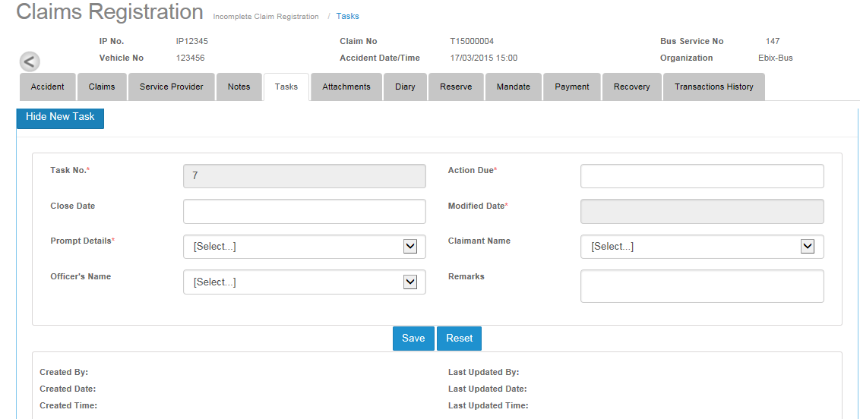

* Tasks number will show system generated number
* User can select Action due from calendar.
* Close date field can only be current date.
* Modified date will have system generated date when tasks are modified.
* Prompt Details will show list of values.
* Claimant name will show list of claimants added on Claims screen.
* Officer’s name will show list of claim officer added on Claims screen.
* Remarks field is simple text field.

# Attachment

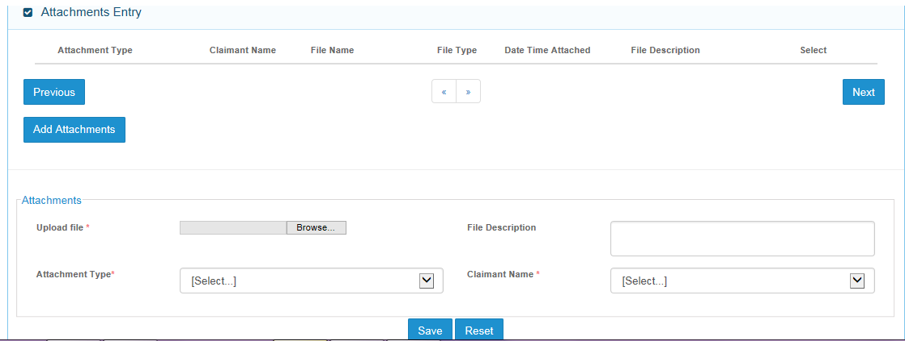

* Upload File: User can click on browse button and select file to upload.
* File Description: User can enter alphanumeric text to describe the file.
* User can attach files of the following type:
  + 3rd party claimants
  + Insured documents
  + Correspondences
  + Internal document
* Claimant name field will show list of added claimants on claims screen.

# Diary Tab Screen

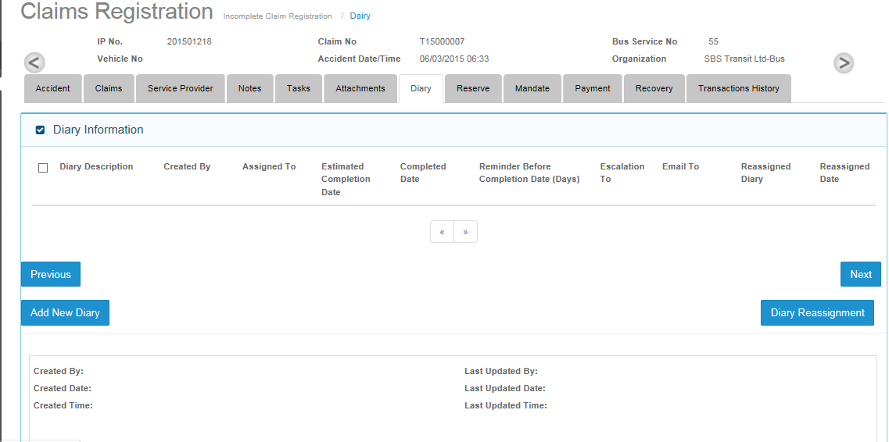

* User can create diary entries by clicking on Add New Diary button.
* Dairy reassignment is a special functionality and user can reassign existing diary entries to another user.
* Only original user (first user to whom diary assigned originally) or user with special permission given, can reassign existing diary entries.

## Add diary Screen

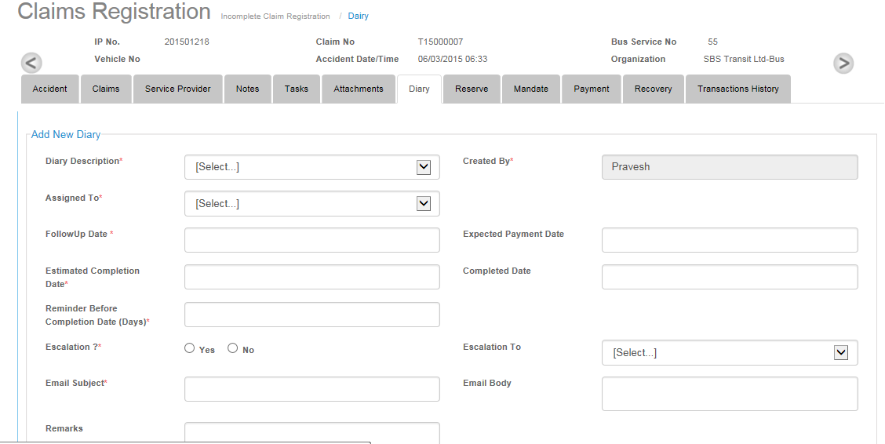

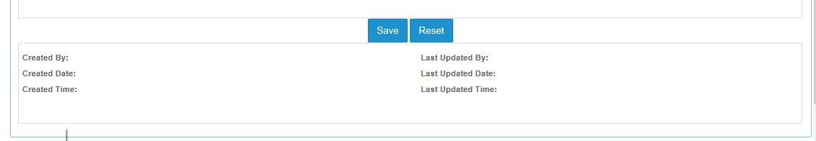

* Created by field will automatically show the user name of the person creating the diary entry.
* Diary description field is having list of values from which user can select any value.
* Assigned To: User can assign diary by selecting user name from the drop down list.
* Escalation To: User can choose from user name list appearing in drop down list for Escalation.

# Reserve Screen

* User can assign unlimited reserve to a claim through reserve screen.
* Reserve can be adjusted from claim adjustment menu by editing amount in reserve movement column’s cell.

## Grid screen

* Reserve grid will show claimant records which have been created on claims screen.
* To assign reserve, user needs to click on edit button.
* User will be able to view add reserve screen after clicking on the Edit button.

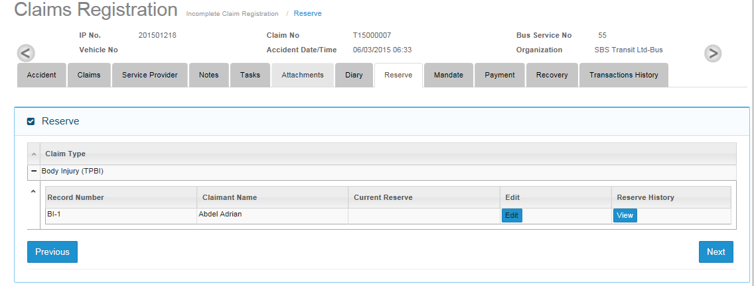

## Reserve Assign screen

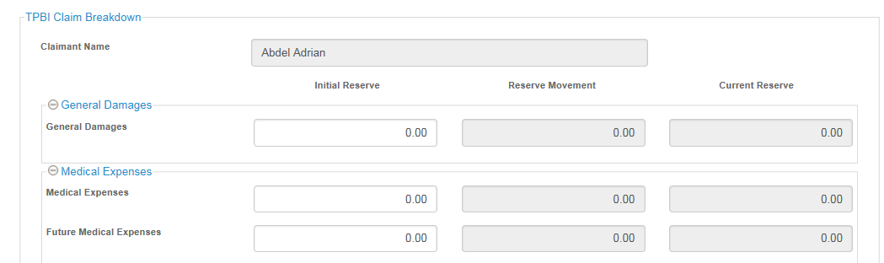 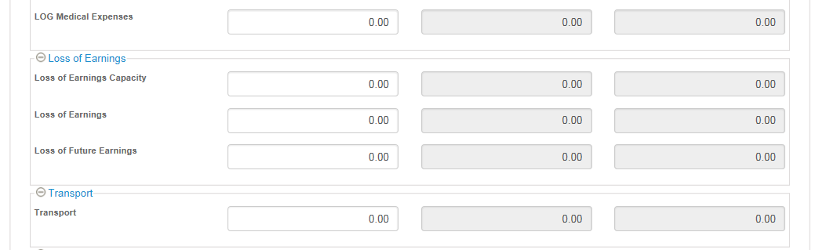 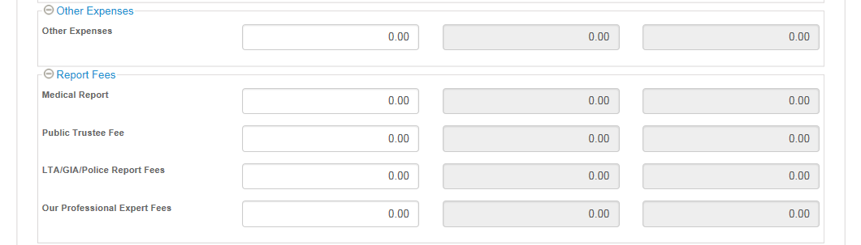 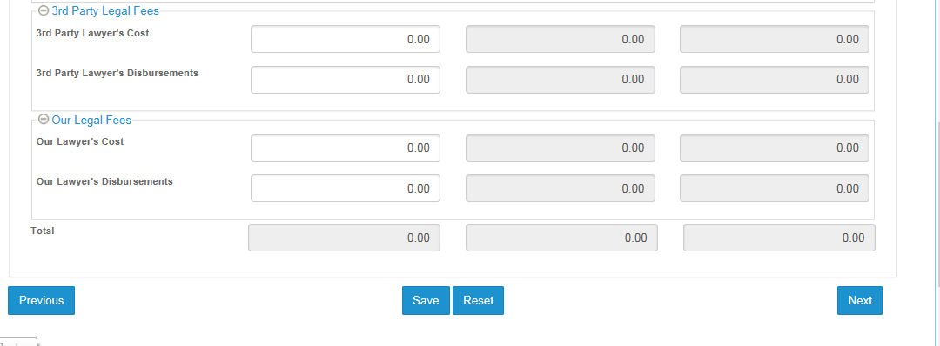

* Claimant will appear automatically in claimant field.
* User can enter reserve amount only once in the Initial Reserve column and cannot be edited after clicking on the Save button. Data in the Initial Reserve column will be non-editable. User can only edit reserve amounts by going to the Claim Adjustment menu and entering reserve movement amounts.

# Mandate Screen

* User can assign mandates to claimant records that have been completed.
* Mandate can be given against reserve created, user is not able to assign mandate values greater than reserve values.
* Validation for mandate is as follows:
  + Mandate must be less then reserve amount.
  + User who has role as supervisor or claim officer and supervisor can approve mandate up to his/her FAL (Financial Authority Limit).
  + Deductible alert indicator: application will prompt User when requested total mandate amount is greater then deductible amount (user can create deductible amounts in Deductible Master for respective organizations).

## Mandate Grid Screen.

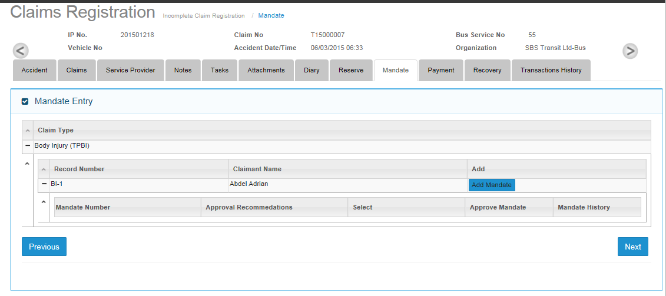

* Grid screen will show records as per following hierarchy:
  + Claim Type -> OD/PD/BI
  + Record Number -> OD1, PD1, BI-1
  + Claimant name corresponding to Record Number
  + Add button to assign mandate against record number
* User can create multiple mandates against single record number.

## Add Mandate Screen

* Add Mandate screen will show three section :
  + Mandate Details: Only Claim Officer role users can input in this section.
  + Supervisor Approval: Only Supervisor role users can input in this section.
  + Claim Breakdown Section
    - 3rd party claim quantum / Claim Quantum : Values populated from reserve screen
    - Our Previous Offers : Free Text to be entered by Claim Officer.
    - 3rd Party Counter-offer : Free Text to be entered by Claim Officer.
    - CO's Recommendations Maximum Offer : To be entered by Claim Officer only.
    - Supervisor's Mandate Maximum Offer : To be entered by Supervisor only.

### Mandate Details section

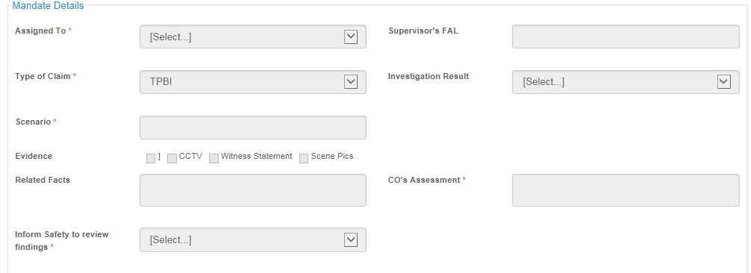

* User can select supervisor from assigned to drop down list.

### Supervisor Approval Section

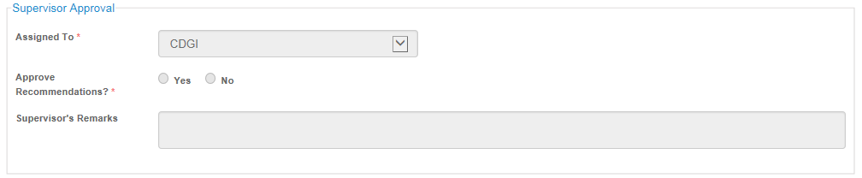

* Assigned to field will automatically show Claim Officer user name.
* Supervisor can either approve or reject CO’s recommendations; this field is compulsory for supervisor to select.

### Claim Breakdown section.

* This section will have similar number of rows as per reserve screen for a particular claimant.
* User will fill corresponding columns as details given in 16.2 section.



# Transaction History

* User can view Transaction history details against a particular claim for the following event on claim registration screens.
  + Add record
  + Update Record
* Following information against a transaction record can be viewed.
  + S.no.
  + Table Name : It will show tab screen name
  + User Name : Name of the user who has done changes
  + Transaction Description
  + Time stamp : time details of changes

